1

Code:

libname college 'C:\Users\Samil\Desktop\Sem 1\Stats for programming\SAS 9.4';

**data** college.cats;

infile 'C:\Users\Samil\Desktop\Sem 1\Stats for programming\SAS 9.4\cats1.txt';

input Name $ Position $ @@;

**run**;

**proc** **print** data=college.cats;

title "Cats Table";

**run**;

Log file:

564 data college.cats;

565 infile 'C:\Users\Samil\Desktop\Sem 1\Stats for programming\SAS 9.4\cats1.txt';

566 input Name $ Position $ @@;

567 run;

NOTE: The infile 'C:\Users\Samil\Desktop\Sem 1\Stats for programming\SAS 9.4\cats1.txt' is:

Filename=C:\Users\Samil\Desktop\Sem 1\Stats for programming\SAS 9.4\cats1.txt,

RECFM=V,LRECL=32767,File Size (bytes)=132,

Last Modified=03 September 2017 11:14:40,

Create Time=03 September 2017 11:14:40

NOTE: 2 records were read from the infile 'C:\Users\Samil\Desktop\Sem 1\Stats for programming\SAS

9.4\cats1.txt'.

The minimum record length was 64.

The maximum record length was 64.

NOTE: SAS went to a new line when INPUT statement reached past the end of a line.

NOTE: The data set COLLEGE.CATS has 8 observations and 2 variables.

NOTE: DATA statement used (Total process time):

real time 0.13 seconds

cpu time 0.00 seconds

568 proc print data=college.cats;

569 title "Cats Table";

570 run;

NOTE: There were 8 observations read from the data set COLLEGE.CATS.

NOTE: PROCEDURE PRINT used (Total process time):

real time 0.30 seconds

cpu time 0.01 seconds

Output file:

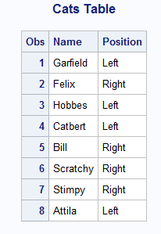

2

Code:

**data** college.dogs;

infile 'C:\Users\Samil\Desktop\Sem 1\Stats for programming\SAS 9.4\dogs1.txt' firstobs=**2**;

input dog $ **1**-**13** conc **14**-**16** sex $ **17**-**21** age **29**-**32** haircoat $**33**-**37** weight **38**-**48**;

**run**;

**proc** **print** data=college.dogs;

title "Dogs Table";

**run**;

Log file:

884 data college.dogs;

885 infile 'C:\Users\Samil\Desktop\Sem 1\Stats for programming\SAS 9.4\dogs1.txt' firstobs=2;

886 input dog $ 1-13 conc 14-16 sex $ 17-21 age 29-32 haircoat $33-37 weight 38-48;

887 run;

NOTE: The infile 'C:\Users\Samil\Desktop\Sem 1\Stats for programming\SAS 9.4\dogs1.txt' is:

Filename=C:\Users\Samil\Desktop\Sem 1\Stats for programming\SAS 9.4\dogs1.txt,

RECFM=V,LRECL=32767,File Size (bytes)=1274,

Last Modified=03 September 2017 11:29:02,

Create Time=03 September 2017 11:29:02

NOTE: 25 records were read from the infile 'C:\Users\Samil\Desktop\Sem 1\Stats for programming\SAS

9.4\dogs1.txt'.

The minimum record length was 48.

The maximum record length was 48.

NOTE: The data set COLLEGE.DOGS has 25 observations and 6 variables.

NOTE: DATA statement used (Total process time):

real time 0.01 seconds

cpu time 0.00 seconds

888 proc print data=college.dogs;

889 title "Dogs Table";

890 run;

NOTE: There were 25 observations read from the data set COLLEGE.DOGS.

NOTE: PROCEDURE PRINT used (Total process time):

real time 0.11 seconds

cpu time 0.01 seconds

Output:

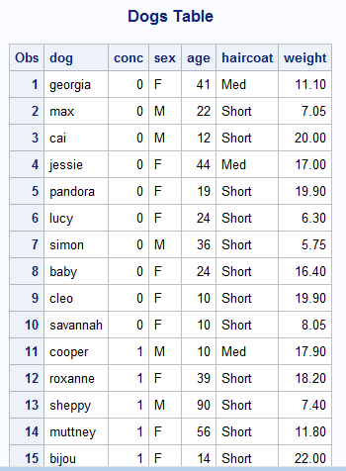

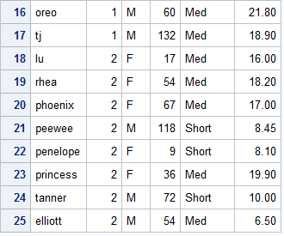

3

Code:

libname college 'C:\Users\Samil\Desktop\Sem 1\Stats for programming\SAS 9.4';

**data** college.bread;

infile datalines firstobs=**3** dlm=',';

input dough $ water oil sugar salt dry_milk flour yeast wheat oregano eggs;

datalines ;

dough,water, oil,sugar,salt,dry milk,flour,yeast,wheat,oregano,eggs

type,(cup),(tblsp),(tblsp),(tsp),(tblsp),(cup),(tsp),(cup),(tsp),(count)

white,1,2,2,1.25,1.5,3,2,0,0,0

French,1.125,0,1.5,1,0,3.5,2,0,0,0

wheat,1.5,2,2,2,0,3,2.25,0.75,0,0

Italian,1.125,2,3,1.5,2,3.25,1.5,0,2,0

pizza,0.75,1,1,0.5,1,2.25,1,0,0,0

bagel,1,0,1.5,1,0,3,2.25,0,0,0

pretzel,1.25,1,2,1,0,3.5,3,0,0,1

egg,0.75,1.5,2,1.5,3,3,2.25,0,0,1

milk,1,2,0.5,1.5,5.33,3,1.75,0,0,0

foccacia,1,5.33,2,1,0,3,1.5,0,1,0

rolls,0.75,3,3,1,0,3.25,1.5,0,0,1

;

**run**;

**proc** **print** data=college.bread;

title "Bread Table";

**run**;

Log file:

518 data college.bread;

519 infile datalines firstobs=3 dlm=',';

520 input dough $ water oil sugar salt dry_milk flour yeast wheat oregano eggs;

521 datalines ;

NOTE: The data set COLLEGE.BREAD has 11 observations and 11 variables.

NOTE: DATA statement used (Total process time):

real time 0.01 seconds

cpu time 0.01 seconds

535 ;

536 run;

537

538 proc print data=college.bread;

539 title "Bread Table";

540 run;

NOTE: There were 11 observations read from the data set COLLEGE.BREAD.

NOTE: PROCEDURE PRINT used (Total process time):

real time 0.13 seconds

cpu time 0.00 seconds

Output file:

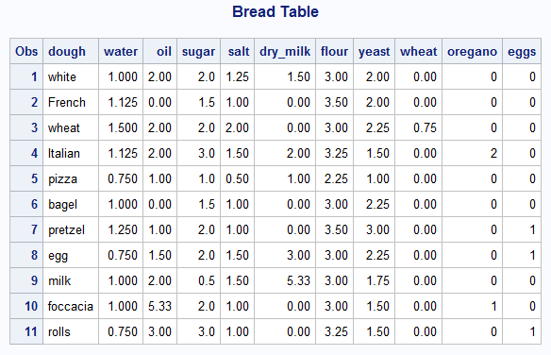

4

Code:

libname college 'C:\Users\Samil\Desktop\Sem 1\Stats for programming\SAS 9.4';

**data** college.grades;

infile datalines dlm='/';

input Name $ Maths Sci Grade $ Pt;

datalines ;

Ann/84/90/A-/0

Bill/78/84/B/0

Cathy/95/89/A/1

David/84/88/B+/1

;

**run**;

**proc** **print** data=college.grades;

Title "Grades";

**run**;

Log File:

159 data college.grades;

160 infile datalines dlm='/';

161 input Name $ Maths Sci Grade $ Pt;

162 datalines ;

NOTE: The data set COLLEGE.GRADES has 4 observations and 5 variables.

NOTE: DATA statement used (Total process time):

real time 0.04 seconds

cpu time 0.04 seconds

167 ;

168 run;

169

170 proc print data=college.grades;

171 Title "Grades";

172 run;

NOTE: There were 4 observations read from the data set COLLEGE.GRADES.

NOTE: PROCEDURE PRINT used (Total process time):

real time 0.11 seconds

cpu time 0.01 seconds

Output:

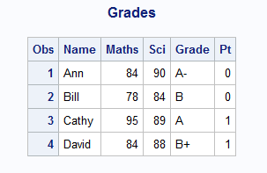

5

Code:

libname college 'C:\Users\Samil\Desktop\Sem 1\Stats for programming\SAS 9.4';

**data** college.soccer;

infile 'C:\Users\Samil\Desktop\Sem 1\Stats for programming\SAS 9.4\soccer.txt';

input number $ / firstname $ lastname $ / code $ / feet $1. inches **3**-**4** / level $ / jersey $;

**run**;

**proc** **print** data=college.soccer;

Title "Soccer Team";

**run**;

Log file:

635 data college.soccer;

636 infile 'C:\Users\Samil\Desktop\Sem 1\Stats for programming\SAS 9.4\soccer.txt';

637 input number $ / firstname $ lastname $ / code $ / feet $1. inches 3-4 / level $ / jersey $;

638 run;

NOTE: The infile 'C:\Users\Samil\Desktop\Sem 1\Stats for programming\SAS 9.4\soccer.txt' is:

Filename=C:\Users\Samil\Desktop\Sem 1\Stats for programming\SAS 9.4\soccer.txt,

RECFM=V,LRECL=32767,File Size (bytes)=4608,

Last Modified=03 September 2017 17:10:25,

Create Time=03 September 2017 17:11:05

NOTE: 192 records were read from the infile 'C:\Users\Samil\Desktop\Sem 1\Stats for programming\SAS

9.4\soccer.txt'.

The minimum record length was 22.

The maximum record length was 22.

NOTE: The data set COLLEGE.SOCCER has 32 observations and 8 variables.

NOTE: DATA statement used (Total process time):

real time 0.01 seconds

cpu time 0.03 seconds

639

640 proc print data=college.soccer;

641 Title "Soccer Team";

642 run;

NOTE: There were 32 observations read from the data set COLLEGE.SOCCER.

NOTE: PROCEDURE PRINT used (Total process time):

real time 0.10 seconds

cpu time 0.03 seconds

Output:

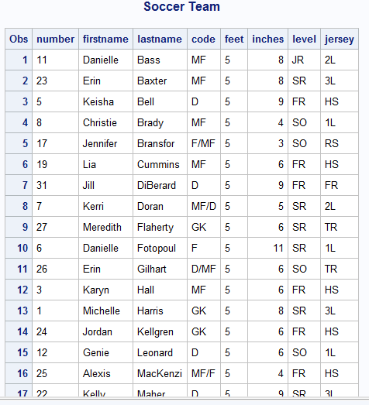

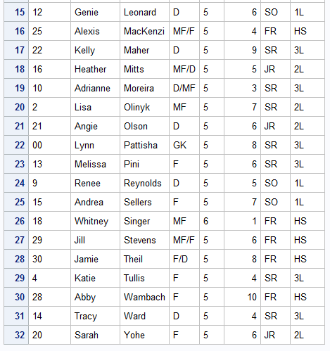

6

Code:

libname college 'C:\Users\Samil\Desktop\Sem 1\Stats for programming\SAS 9.4';

**data** college.cats3;

infile 'C:\Users\Samil\Desktop\Sem 1\Stats for programming\SAS 9.4\cats3.txt' firstobs=**2**;

input Cat $ Side $ Week_0 Week_1 Week_2;

**run**;

**proc** **print** data=college.cats3;

Title "Cats";

**run**;

Log File:

660 data college.cats3;

661 infile 'C:\Users\Samil\Desktop\Sem 1\Stats for programming\SAS 9.4\cats3.txt' firstobs=2;

662 input Cat $ Side $ Week_0 Week_1 Week_2;

663 run;

NOTE: The infile 'C:\Users\Samil\Desktop\Sem 1\Stats for programming\SAS 9.4\cats3.txt' is:

Filename=C:\Users\Samil\Desktop\Sem 1\Stats for programming\SAS 9.4\cats3.txt,

RECFM=V,LRECL=32767,File Size (bytes)=394,

Last Modified=03 September 2017 17:39:20,

Create Time=03 September 2017 17:39:20

NOTE: 8 records were read from the infile 'C:\Users\Samil\Desktop\Sem 1\Stats for programming\SAS

9.4\cats3.txt'.

The minimum record length was 41.

The maximum record length was 43.

NOTE: The data set COLLEGE.CATS3 has 8 observations and 5 variables.

NOTE: DATA statement used (Total process time):

real time 0.02 seconds

cpu time 0.01 seconds

664

665 proc print data=college.cats3;

666 Title "Cats";

667 run;

NOTE: There were 8 observations read from the data set COLLEGE.CATS3.

NOTE: PROCEDURE PRINT used (Total process time):

real time 0.13 seconds

cpu time 0.01 seconds

Output:

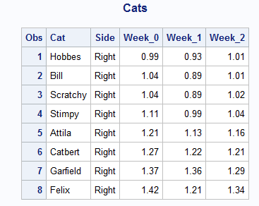

7

Code:

**data** college.manatees;

infile 'C:\Users\Samil\Desktop\Sem 1\Stats for programming\SAS 9.4\manatees.txt'firstobs=**2** expandtabs;

input YEAR WATERC LOCK RELAT PERIN NATUR UNDET;

**run**;

**proc** **print** data=college.manatees;

Title "Manatees";

**run**;

Log File:

694 input YEAR WATERC LOCK RELAT PERIN NATUR UNDET;

695 run;

NOTE: The infile 'C:\Users\Samil\Desktop\Sem 1\Stats for programming\SAS 9.4\manatees.txt' is:

Filename=C:\Users\Samil\Desktop\Sem 1\Stats for programming\SAS 9.4\manatees.txt,

RECFM=V,LRECL=32767,File Size (bytes)=540,

Last Modified=03 September 2017 17:51:59,

Create Time=03 September 2017 17:54:48

NOTE: 23 records were read from the infile 'C:\Users\Samil\Desktop\Sem 1\Stats for programming\SAS

9.4\manatees.txt'.

The minimum record length was 17.

The maximum record length was 23.

NOTE: The data set COLLEGE.MANATEES has 23 observations and 7 variables.

NOTE: DATA statement used (Total process time):

real time 0.02 seconds

cpu time 0.01 seconds

696

697 proc print data=college.manatees;

698 Title "Manatees";

699 run;

NOTE: There were 23 observations read from the data set COLLEGE.MANATEES.

NOTE: PROCEDURE PRINT used (Total process time):

real time 0.11 seconds

cpu time 0.04 seconds

Output:

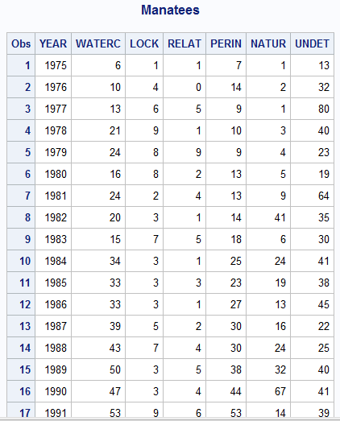

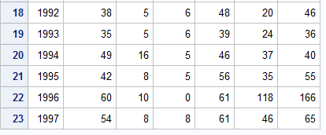

8

Code:

libname college 'C:\Users\Samil\Desktop\Sem 1\Stats for programming\SAS 9.4';

**data** college.dogs2;

infile 'C:\Users\Samil\Desktop\Sem 1\Stats for programming\SAS 9.4\dogs2.txt' firstobs=**3** expandtabs;

input Dog_Name $ Week_0 Week_2 Week_4;

**run**;

**proc** **print** data=college.dogs2;

Title "Dogs Table";

**run**;

Log file:

35 data college.dogs2;

36 infile 'C:\Users\Samil\Desktop\Sem 1\Stats for programming\SAS 9.4\dogs2.txt' firstobs=3

36 ! expandtabs;

37 input Dog_Name $ Week_0 Week_2 Week_4;

38 run;

NOTE: The infile 'C:\Users\Samil\Desktop\Sem 1\Stats for programming\SAS 9.4\dogs2.txt' is:

Filename=C:\Users\Samil\Desktop\Sem 1\Stats for programming\SAS 9.4\dogs2.txt,

RECFM=V,LRECL=32767,File Size (bytes)=688,

Last Modified=04 September 2017 11:52:09,

Create Time=04 September 2017 11:52:53

NOTE: 25 records were read from the infile 'C:\Users\Samil\Desktop\Sem 1\Stats for programming\SAS

9.4\dogs2.txt'.

The minimum record length was 23.

The maximum record length was 26.

NOTE: The data set COLLEGE.DOGS2 has 25 observations and 4 variables.

NOTE: DATA statement used (Total process time):

real time 0.03 seconds

cpu time 0.01 seconds

39

40 proc print data=college.dogs2;

41 Title "Dogs Table";

42 run;

NOTE: There were 25 observations read from the data set COLLEGE.DOGS2.

NOTE: PROCEDURE PRINT used (Total process time):

real time 0.41 seconds

cpu time 0.01 seconds

Output:

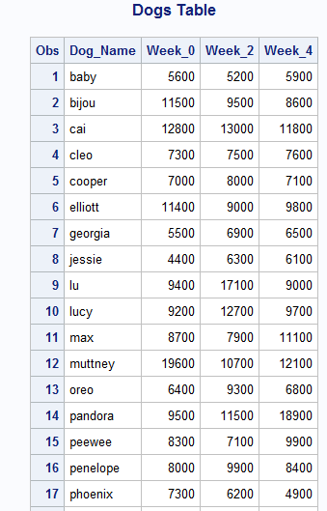

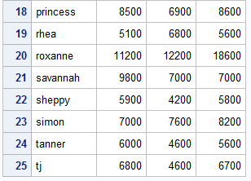

9

Code:

*libname college 'C:\Users\Samil\Desktop\Sem 1\Stats for programming\SAS 9.4';

**data** Portfolio;

infile 'C:\Users\Samil\Desktop\Sem 1\Stats for programming\SAS 9.4\stocks.txt';

input Symbol $ Price No_of_Shares;

*Samil Shah added a column Value on 09-04-2017;

Value = Price * No_of_Shares;

**run**;

**proc** **print** data=Portfolio;

Title "Stocks Table";

**run**;

/*data college.stocks;

set Portfolio;

run;*/

**proc** **means** data=Portfolio;

var Price No_of_Shares;

title "Average";

**run**;

Log File:

584 *libname college 'C:\Users\Samil\Desktop\Sem 1\Stats for programming\SAS 9.4';

585 data Portfolio;

586 infile 'C:\Users\Samil\Desktop\Sem 1\Stats for programming\SAS 9.4\stocks.txt';

587 input Symbol $ Price No_of_Shares;

588 *Samil Shah added a column Value on 09-04-2017;

589 Value = Price * No_of_Shares;

590 run;

NOTE: The infile 'C:\Users\Samil\Desktop\Sem 1\Stats for programming\SAS 9.4\stocks.txt' is:

Filename=C:\Users\Samil\Desktop\Sem 1\Stats for programming\SAS 9.4\stocks.txt,

RECFM=V,LRECL=32767,File Size (bytes)=88,

Last Modified=04 September 2017 14:15:49,

Create Time=04 September 2017 14:17:12

NOTE: 6 records were read from the infile 'C:\Users\Samil\Desktop\Sem 1\Stats for programming\SAS

9.4\stocks.txt'.

The minimum record length was 12.

The maximum record length was 14.

NOTE: The data set WORK.PORTFOLIO has 6 observations and 4 variables.

NOTE: DATA statement used (Total process time):

real time 0.06 seconds

cpu time 0.06 seconds

591

592 proc print data=Portfolio;

593 Title "Stocks Table";

594 run;

NOTE: There were 6 observations read from the data set WORK.PORTFOLIO.

NOTE: PROCEDURE PRINT used (Total process time):

real time 0.18 seconds

cpu time 0.07 seconds

595

596 /*data college.stocks;

597 set Portfolio;

598 run;*/

599

600 proc means data=Portfolio;

601 var Price No_of_Shares;

602 title "Average";

603 run;

NOTE: There were 6 observations read from the data set WORK.PORTFOLIO.

NOTE: PROCEDURE MEANS used (Total process time):

real time 0.14 seconds

cpu time 0.07 seconds

Output:

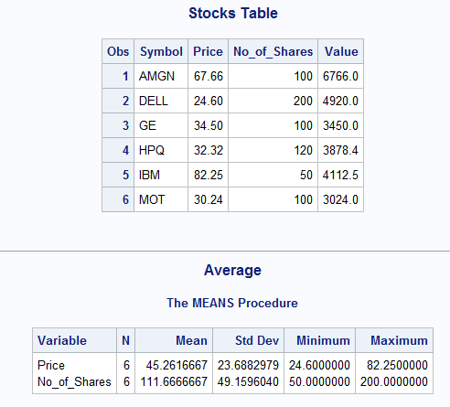

10

Code:

**data** prob2;

input ID $

Height /*in inches*/

Weight /*in pounds*/

SBP /*systolic BP*/

DBP /*diastolic BP*/;

Wtkg = Weight/**2.2** /*in kg*/;

HtCm= (Height\***2.54**)/*in cm*/;

AveBP= DBP+(SBP-DBP)/**3** /*Average blood pressure*/;

HtPolynomial= **2**\*HtCm\*\***2**+**1.5**\*HtCm\*\***3**;

datalines;

001 68 150 110 70

002 73 240 150 90

003 62 101 120 80

;

**run**;

title “Listing of PROB2”;

**proc** **print** data=prob2;

**run**;

Log File:

564 data prob2;

565 input ID $

566 Height /*in inches*/

567 Weight /*in pounds*/

568 SBP /*systolic BP*/

569 DBP /*diastolic BP*/;

570 Wtkg = Weight/2.2 /*in kg*/;

571 HtCm= (Height*2.54)/*in cm*/;

572 AveBP= DBP+(SBP-DBP)/3 /*Average blood pressure*/;

573 HtPolynomial= 2*HtCm**2+1.5*HtCm**3;

574 datalines;

NOTE: The data set WORK.PROB2 has 3 observations and 9 variables.

NOTE: DATA statement used (Total process time):

real time 0.03 seconds

cpu time 0.03 seconds

578 ;

579 run;

580

581 title “Listing of PROB2”;

582 proc print data=prob2;

583 run;

NOTE: There were 3 observations read from the data set WORK.PROB2.

NOTE: PROCEDURE PRINT used (Total process time):

real time 0.13 seconds

cpu time 0.04 seconds

Output:

